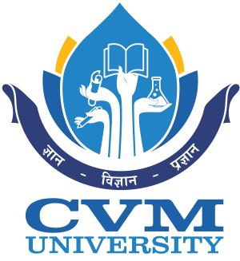
APPLICATION FORM FOR CME
IN
PRASUTI TANTRA AND STRI ROGA
(3rd January 2022 to 8th January 2022)

(Sponsored by Ministry of AYUSH, Govt. of India, New Delhi
Co-ordinated by Rashtriya Ayurved Vidyapeeth, New Delhi)
Recent Passport size photo attested by Controlling Authority

To
The Director
G. J. Patel Institute of Ayurvedic Studies & Research
ADIT campus, Behind GIDC
New Vallabh Vidyanagar,
Anand, Gujarat
Pin code - 388121

I hereby apply for CME in PRASUTI TANTRA AND STRI ROGA to be held at your Institute as mentioned in the Notification.

1. | Name in full (Block letters)
2. | Sex
3. | Designation
4. | Age and date of Birth
5. | AADHAR No.
6. | NCISM Unique Teacher Code
7. | Name of the College/Department/ Institution presently working
8. | Official address / phone number and  Fax number
9. | Permanent Residential Address and  Phone Number  Mobile No.  Email address
10. | Qualifications
11. | Date of entry into service
12. | Total Teaching experience
13. | Registration board and Reg. No.
14. | Whether he/she has attended any CME sponsored by AYUSH Ministry in the last five years? If yes, give the details (If required, additional sheet can be attached.) Whether applied for any CME after April 2021, if accepted will be attending? attach additional sheet for details. | Up to March 2021 | April 2021 to till date

DECLARATION
I hereby declare that the particular/information furnished above is true to the best of my knowledge and belief.

Date:
Place:
Name & Signature of the Applicant

RECOMMENDATION OF HEAD OF THE INSTITUTION/ CONTROLLING AUTHORITY
The application for PRASUTI TANTRA AND STRI ROGA CME of
Dr.…........................................................................................... is forwarded for consideration.

Signature of Head of the Institution/Controlling Authority
along with seal.

Date:

Place:

